**Reneal 2023B Box and Project Notes**

**Version 1**

IMPORTANT NOTES

1. Ten new schools:
   1. Selebu, Kilolo, Udzungwa, Nyalumbu in Kilolo DC, Iringa Region
   2. Mboga, Mdaula, Msata, Mandela in Chalinze DC, Pwani Region
   3. Mkonoo in Arusha CC, Arusha Region
   4. Banjika in Karatu DC, Arusha Region
2. **VERY IMPORTANT**: There were two school changes after the boxes were packed and labeled.   
   Ubena is changed to Mboga  
   Tarakea is changed to Mandela

**THE UBENA AND TARAKEA SERVERS MUST HAVE NEW VPN FILES (FOR MBOGA AND MANDELA) PUT IN THEIR SERVERS BEFORE THEY ARE TAKEN TO THE SCHOOLS**. Neal will send runner files to Erick to do that update.

**All of the equipment labeled as “Ubena” should go to Mboga  
All of the equipment labeled as “Tarakea” should go to Mandela**

1. **VERY IMPORTANT**: Some items have Bureau Veritas Inspection Tape. Do not remove or disturb this tape until the items are at the school!

The TCRA required an ecolevy inspection for the used Reneal equipment for this shipment. An inspector came to our home and did a random sample of a laptop, mouse, keyboard, and TIB desktop. After inspection, these items were marked with special Bureau Veritas inspection tape. The inspector also put inspection tape on a Reneal server, network switch, laptop adapter, US-TZ connector, wireless router, and TIB box with the wireless router used during the inspection testing.

ALL ITEMS WITH BUREAU VERITAS INSPECTION TAPE ARE IN THE FOLLOWING BOXES: A, AA, and FF.

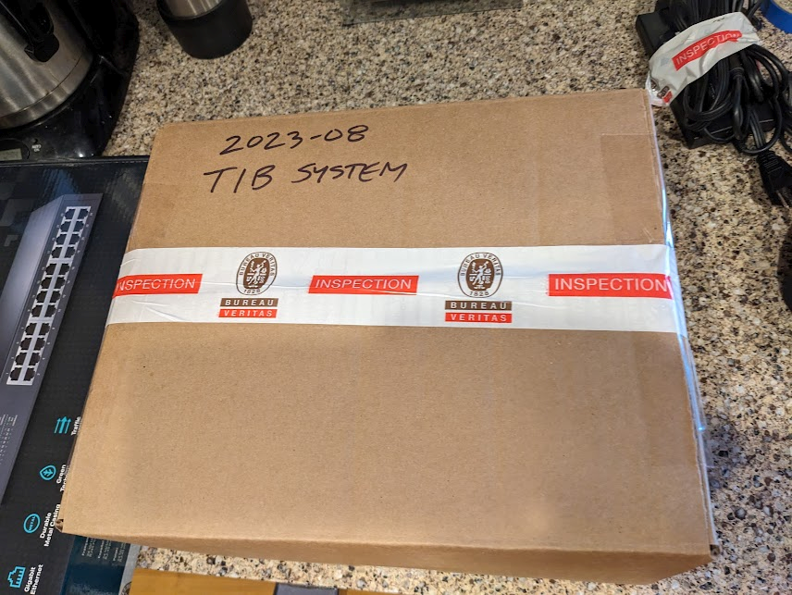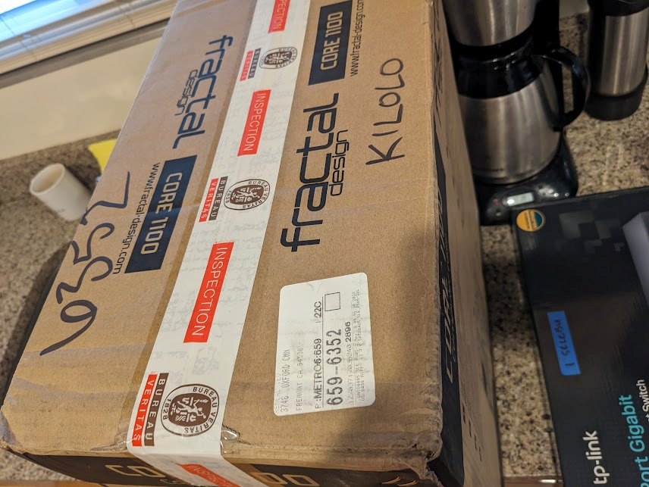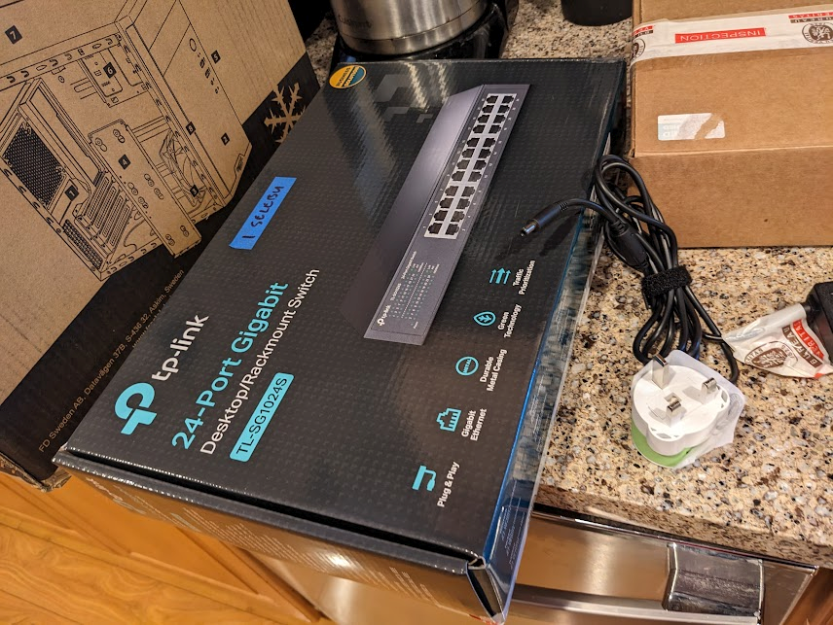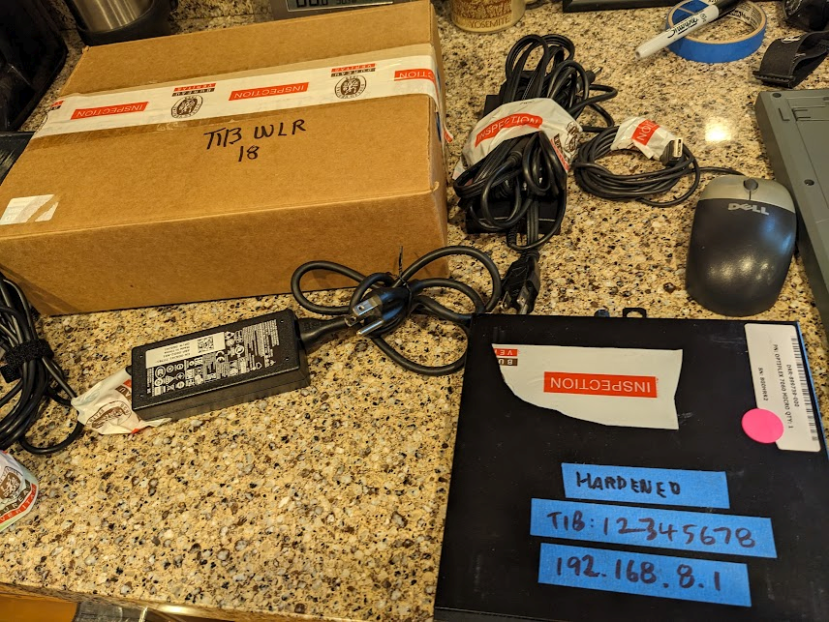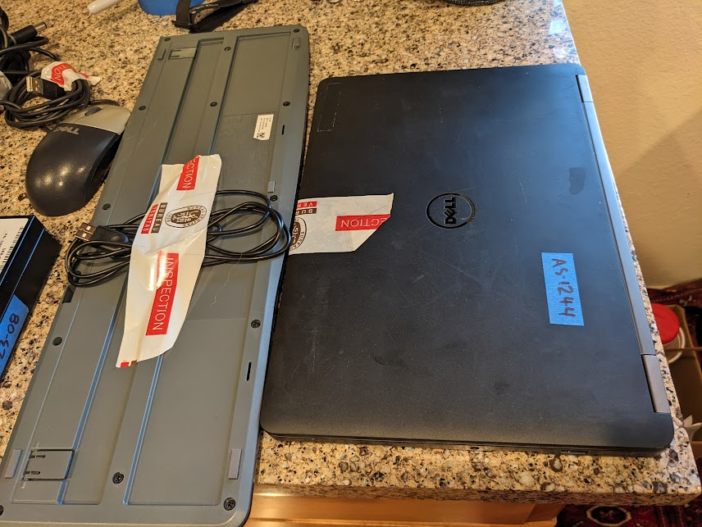

Again, do not remove or disturb the inspection tape until items are at the school.

1. There are twenty Teacher in a Box (TIB) systems (small desktop and power adapter, wireless and power adapter, Ethernet cable, TZ plug, instructions and donation letter). Each TIB system is in a separate box for easy deployment. Do not remove items from the boxes until the box is delivered to the school.
2. Terrawatu is donating money for the UPS, voltage stabilizer, and UTP cable for the Mkonoo lab. So the donation letter for Mkonoo is different, it will be for both Reneal and Terrawatu. Someone from Terrawatu must sign that letter. Reneal, Terrawatu, and the school each receive a copy of the signed Mkonoo letter.
3. We had to quickly pack and seal the Kilolo server box during the Bureau Veritas inspection. I accidentally put the wrong donation letters in the sys admin manual – please discard these incorrect donation letters. The correct donation letters for Kilolo are in the Kilolo network switch box.
4. Fifty of the E7240 laptops have laptop batteries installed. DO NOT REMOVE THESE BATTERIES. They are required for reliable turn-on. There are also some E7240 laptops with dead CMOS battery – do not try to replace them, they are very difficult to access.
5. In this shipment, the servers have different video outputs because they use different motherboards. Many of the servers do not have VGA outputs now. The monitors have different video inputs. There are many different kinds of video cables in this shipment to match the servers to the monitors. **DO NOT EXCHANGE MONITORS**, it was very difficult to find the right cables. Everything is numbered, it is very important to keep the correct cable with the correct monitor and correct server.
6. Please collect any equipment donated by Apto that has failed and save it at the RO. We must return any dead items to Apto Solutions for recycling if we cannot fix them.

Summary of Box Contents

1. Here is the organization of the boxes:
   1. Boxes A-T have laptops/adapters/mice, and a keyboard for each of the 10 new schools. There are two boxes per new school (total of 20 boxes).
   2. Boxes U, V and W have laptops/adapters/mice for replacement/addition. There are ten laptops/adapters/mice in each box, and there are three boxes.
   3. Box X has 6 monitor screens (Selebu, Ubena/Mboga, Msata, Tarakea/Mandela, Mkonoo, Banjika).
   4. Box JJ has 5 monitor screens (Kilolo, Udzungwa, Nyalumbu, Mdaula, and the spare monitor), the HDMI/power cables for the spare monitor, 5 bags of RJ45 connectors (100 connectors/bag), and a box of Team supplies. The spare monitor and its cables should go to Ashura’s warehouse.
   5. Box Y has all 11 monitor stands and bases, a bag of cable zip ties, and a box of Team supplies. The monitor stands and bases are marked with the same number as the monitor screen.
   6. Boxes AA, BB, CC, DD, and EE have the following:
      1. Servers and network switches for the 10 new schools (two per box).
      2. The power cable for the server, the video cable, the power cable for the monitor and the sys admin manual are inside each server box. Two copies of the donation letter are inside the sys admin manual. PLEASE NOTE: The donation letter for Mkonoo SS is a joint Reneal-Terrawatu lab. Please have Boris from Terrawatu and the school sign those letters. Reneal, Terrawatu, and the school each receive a copy of the signed Mkonoo letter.
2. Monitor information:

Not all of the servers in this shipment have VGA outputs. In the future, when you have a server monitor that is not working, you will need to be careful to find a monitor with the correct output and a correct cable to replace it.

In this shipment, there are several different cables that are needed to connect the servers to the monitors. Below is the information. The correct monitor cable should be in each server box that will match the monitor for that school. Be very careful not to mix them up.

| **Monitor**  **Label** | **School** | **Monitor Cable Type** | **Monitor**  **Cables** | **Monitor**  **Screen** | **Monitor Stand/Base** |
| --- | --- | --- | --- | --- | --- |
| 1 | Selebu | HDMI-DP | Box AA | Box X | Box Y |
| 2 | Kilolo | DVI-DVI | Box AA | Box JJ | Box Y |
| 3 | Udzungwa | HDMI-DVI | Box BB | Box JJ | Box Y |
| 4 | Nyalumbu | HDMI-DVI | Box BB | Box JJ | Box Y |
| 5 | Ubena/Mboga | DP-DP | Box CC | Box X | Box Y |
| 6 | Mdaula | HDMI-VGA | Box CC | Box JJ | Box Y |
| 7 | Msata | HDMI-VGA | Box DD | Box X | Box Y |
| 8 | Tarakea/Mandela | HDMI-HDMI | Box DD | Box X | Box Y |
| 9 | Mkonoo | VGA-VGA | Box EE | Box X | Box Y |
| 10 | Banjika | VGA-VGA | Box EE | Box X | Box Y |
| 11 | Spare | HDMI-HDMI | Box JJ | Box JJ | Box Y |

[Each monitor part is labeled with the number.]

The spare monitor (#11) has HDMI, Display Port (DP), and VGA inputs. I have included an HDMI-HDMI cable for it in Box JJ.

1. The following boxes have all of the equipment for the 10 new schools:
   1. Selebu Secondary School: A, B, part of AA, part of X, part of Y
   2. Kilolo Secondary School: C, D, part of AA, part of JJ, part of Y
   3. Udzungwa Secondary School: E, F, part of BB, part of JJ, part of Y
   4. Nyalumbu Secondary School: G, H, part of BB, part of JJ, part of Y
   5. Ubena/Mboga Secondary School: I, J, part of CC, part of X, part of Y
   6. Mdaula Secondary School: K, L, part of CC, part of JJ, part of Y
   7. Msata Secondary School: M, N, part of DD, part of X, part of Y
   8. Tarakea/Mandela Secondary School: O, P, part DD, part of X, part of Y
   9. Mkonoo Secondary School: Q, R, part of EE, part of X, part of Y
   10. Banjika Secondary School, S, T, part of EE, part of X, part of Y
2. Team supplies are in Box JJ and Box Y.

There are RJ45s (5 bags of 100 connectors/bag) in Box JJ and a bag of cable zip ties in Box Y, for installing at the new schools.

Here are two boxes (one in Box JJ and one in Box Y) with the tools and supplies for each Team member. They are in a bag labeled with each Team members name. PLEASE GET YOUR TOOLS IMMEDIATELY WHEN THE BOXES ARRIVE, so nothing is stolen again.

|  |  |  |  |  |  |  |
| --- | --- | --- | --- | --- | --- | --- |
|  | **Ashura** | **Erick** | **James** | **Juma** | **Jastin** | **Robert** |
| **Crimping Tool** |  |  | *X* |  | *X* |  |
| **Stripping Tool** |  |  | *X* |  | *X* |  |
| **Cable Tester** |  |  |  |  | *X* |  |
| **Knife** |  |  | *X* |  | *X* |  |
| **Scissors** |  |  | *X* |  | *X* |  |
| **Screwdrivers** |  |  | *X* |  | *X* |  |
| **Blue tape** | *X* | *X* | *X* | *X* | *X* | *X* |
| **Sharpie pen** | *X* | *X* | *X* | *X* | *X* | *X* |
| **Copper tape** |  | *X* | *X* |  | *X* |  |
| **Electrical tape** |  |  | *X* | *X* | *X* |  |
| **Multiplug** |  |  | *X* |  | *X* |  |
| **Spudger set** |  |  |  |  | *X* |  |
| **Torx6 screwdriver** | *X* | *X* | *X* | *X* | *X* | *X* |
| **Clear tape (box closing)** | *X* | *X* | *X* | *X* | *X* | *X* |

* 1. The clear tape for each Team member is for closing and sealing boxes. Please use that instead of blue tape, clear tape is more secure than blue tape for boxes.
  2. Ashura: extra clear tape
  3. Special Team Items (held by Juma): EEPROM programmer, replacement RAM sticks
  4. There are 3 Dell power adapter converters (7.4mm regular Dell adapter to 4.5mm small Dell adapter) for the TIB systems, for Ashura’s toolkit.
  5. Samsung laptop adapter for Einoti: distribute as soon as possible [Ashura]
  6. MacBook adapters (2-Mlangarini, 2-Einoti): distribute as soon as possible [Robert]

Arusha Equipment

|  |  |  |
| --- | --- | --- |
| **Item** | **Purchased** | **Destination** |
| Uninterruptible power supply (UPS) | 10 | All schools |
| Voltage stabilizer, 500VA | 10 | All schools |
| Power universal extensions (5 outlets) | 50 | 5 each for all schools |

PLEASE NOTE: We have purchased 5 boxes of UTP cable from Fatma’s shop. Please let me know if we need more.

Installation Notes

Here is a list of what you will need at each new school being installed: server, power cord for server, sysadmin manual and donation letters, keyboard, monitor screen, monitor stand (2 pieces), power and video cables for monitor, network switch and power cord, 20 laptops, 20 laptop adapters, 21 mice, UPS, 3 special UPS cords OR a multiplug (for server, monitor, and network switch), voltage stabilizer, 5 extensions, Cat6 cable, RJ45 connectors, zip ties, blue tape, pens, cable clips, screws for mounting the switch, hammer and drill, your personal supplies and tools, power meter, and Reneal T-shirts.

1. Please use Erick’s installation checklist to make sure all steps are completed and you gather all the needed information about the new school plus the signed donation letters.
2. PLEASE NOTE: UPS should be charged for 12 hours before it is used the first time.
3. Before you plug anything in, check the computer room voltage with the power meter to make sure it is around 220 volts and stable.
4. Neal turned off the power supply switch on each server, so you will need to turn it on before you start the server.
5. We did not put security stickers on the server this time, but please do not open the server unless you experience problems.

If the server does not start properly, take off the cover and check the power connectors to the motherboard, check any SATA cables, make sure the RAM is inserted fully, and check the network cards to make sure they are inserted completely. Most of the storage is now SSD attached to the motherboard, so they should not need to be check since they are firmly attached.

1. I have the specifications for all of the laptops in a spreadsheet. Please leave the blue tape with the number on the laptop, for identification. “AS” with a number means the laptop/adapter was donated by Apto Solutions.

Spare Laptops

There are thirty laptops for replacing/adding units at schools (Boxes U, V, W). Please contact me for laptop numbers when we are ready to do this. Proposal is:

1. Mukulat: 5
2. Einoti: 5
3. Amani Abeid: 5
4. Oldadai: 5
5. Ilkiding’a: 5
6. Sokon2: 5

Laptop Notes

Laptops for the 10 new schools are all Dell. All of the Dell adapters should work with any Dell laptop, so the adapters are not labeled with a number. For some Dell laptops, you may see a message about the power adapter not providing enough power to charge the battery, or that it can’t identify the power adapter. Please just hit F3, which will disable future warnings. Then hit F1 to continue the boot.

I changed a lot of CMOS batteries, but you may see some additional CMOS battery failures. For most of the models, it is very easy to replace the CMOS battery using a CR2032 battery, copper tape, and electrical tape. However there are some laptops that had dead CMOS batteries but are very difficult to replace. So, the Super User should just do “F1” on boot, and do not try to change those CMOS batteries. If you should not change the CMOS battery, there is blue tape with a note on the back saying “DO NOT CHANGE CMOS BATTERY.”

Laptops where you will NOT try to change the CMOS battery: Dell Latitude E7240. Please never try to change the CMOS battery on the E7240. It is very difficult, you must take apart the entire laptop.

There are two laptops that need an external keyboard. The extra keyboard is included in each school’s box for those laptops (Tarakea/Mandela and Banjika).

There are two laptops that need a mouse (dead trackpad). These are going to Msata and Udzungwa and will always need a working mouse.

There are 4 laptops that were donated by other people (labeled I-1, I-2, I-3, I-4). Their adapters are marked with that number, please use the correct adapter with each laptop.

Dell Latitude E7240 Turn-on Problem

There are 81 of the E7240 laptops in the shipment. Without a battery, I had several that would not power on immediately. I would have to turn them off, unplug them, turn them on, sometimes several times. Sometimes I just waited with them unplugged, and then they would turn on. Eventually they would come on. And the problem was intermittent, sometimes it would affect some units, and other times, other units.

I had 50 laptop batteries, so 50 of the E7420s have the laptop batteries installed. If the laptop has a battery installed, it seems to turn on reliably. DO NOT REMOVE THE LAPTOP BATTERIES IN THE E7420.

There are 16 E7240s that have a dead CMOS battery. Do not try to replace the CMOS battery, it is very difficult. But these units turn on reliably, you just need to type F1 when it asks, then it will boot.

There are 15 E7240s that do not have a laptop battery installed (AS-1179, AS-1181, AS-1182, AS-1183 AS-1185, AS-1191, AS-1194, AS-1195, AS-1196, AS-1201, AS-1202, AS-1204, AS-1205, AS-1206, AS-1207). They have been working all right, but please be aware that they may not power on immediately. You might have to turn them off, unplug them, and turn them on. They do work, but sometimes just not immediately. I think most of those are in the Spares box.

One of the E7240s, AS-1192, is a little different. The CMOS battery is dead, so you must type F1. It will not boot to the network the first time. So then you need to do CTRL-ALT-DEL to reboot, and then it will boot to the network

Laptop Security: Special Screw to prevent RAM theft

For the E7240, E7250, E7470 computers in this shipment, there are two screws on the back that hold the back cover in place. For each of these laptops, I have replaced one of the regular screws with a “Torx 6” screw (see the picture below). A torx screw is like a 6-pointed star.

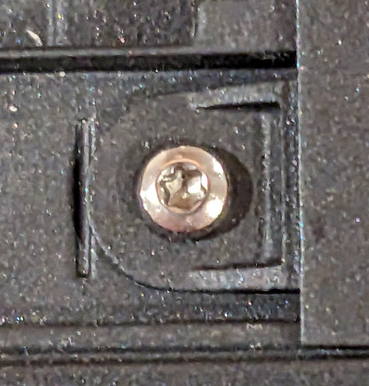

This special screw will hopefully stop people from stealing the RAM. You will each find a Torx 6 screwdriver in your new tools. This can be used to remove the Torx 6 screw if you need to.

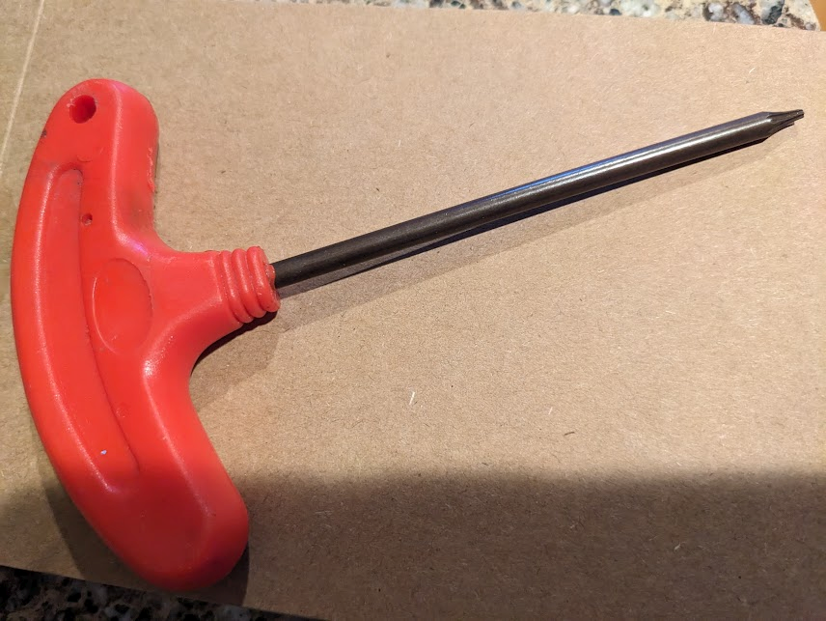

Laptop Security: Set Administrator Password so students cannot enter BIOS

I have set the administrator password on each of the Dell laptops in this shipment. It is set to:

**R3n3al@TZ**

This password locks the BIOS. If you need to change the BIOS, you will need to enter this password to unlock it.

When you set the administrator password for other laptops, it is very important that you use this same password, and be very careful that you have typed it in correctly.

Teacher-in-a-Box Systems

There are twenty Teacher in a Box (TIB) systems. Each complete TIB system is in a separate box that can be delivered to a school. Each box includes: a small desktop computer, the desktop computer power adapter, a wireless router, wireless router power adapter, Ethernet cable, TZ plug, instructions, and two copies of the donation letter. Each TIB system is in a separate box for easy deployment. Do not remove items from the boxes until you are at the school.

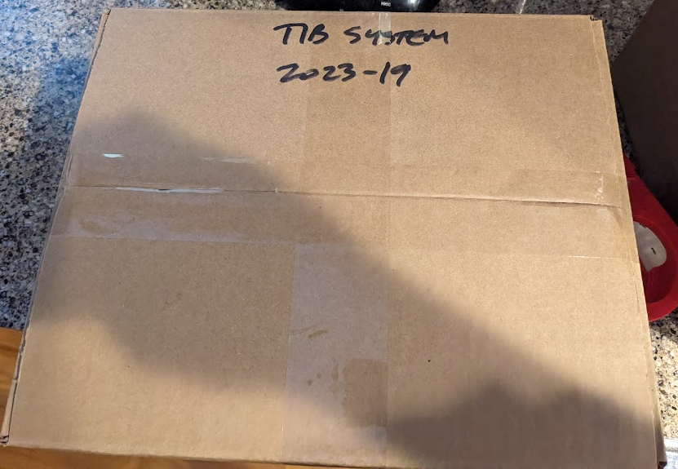

The boxes with TIB systems are FF, GG, HH, and II. There are 5 TIB systems in each of those big boxes.

Neal changed the CMOS batteries for each TIB desktop. However if you ever need to set the BIOS for a TIB system, he has made a video. The BIOS administrator password is set for these desktops to the same password as the laptop BIOS password.

Whenever a TIB system is given to a school, have them sign both copies of the MOU letter in the box. Leave one copy with the school and take the other one. Be sure to write the TIB system number and date on the MOU letter, and send a picture of the signed document to me. TIB is an Australian NGO, and they want to track the deployment places.

The TIB micro desktops are all Dell computers (Optiplex 7040 or 7060). For power, they use a laptop-type adapter. This adapter has a small connector (4.5mm) that plugs into the desktop. This is different than the usual Dell laptop adapter, which is bigger (7.4mm connector).

In the Team Supplies box, I am sending several short 7.4mm-to-4.5mm adapter cables that can be used so that a regular Dell laptop adapter could be used for the TIB system. Ashura should keep these adapter cables in her toolkit. If a TIB system has an adapter failure, a regular Dell laptop adapter plus this short cable can be used to replace it.

**Box Contents (sorted by school): NOTE UBENA->MBOGA, TARAKEA->MANDELA**

|  |  |  |  |
| --- | --- | --- | --- |
| **Box** | **Item** | **Quantity** | **Destination** |
| A | Laptop | 8 | Selebu |
| A | Laptop adapter | 20 | Selebu |
| A | Mouse | 21 | Selebu |
| A | Keyboard | 1 | Selebu |
|  |  |  |  |
| **Box** | **Item** | **Quantity** | **Destination** |
| B | Laptop | 12 | Selebu |
|  |  |  |  |
| **Box** | **Item** | **Quantity** | **Destination** |
| C | Laptop | 8 | Kilolo |
| C | Laptop adapter | 20 | Kilolo |
| C | Mouse | 21 | Kilolo |
| C | Keyboard | 1 | Kilolo |
|  |  |  |  |
| **Box** | **Item** | **Quantity** | **Destination** |
| D | Laptop | 12 | Kilolo |
|  |  |  |  |
| **Box** | **Item** | **Quantity** | **Destination** |
| E | Laptop | 8 | Udzungwa |
| E | Laptop adapter | 20 | Udzungwa |
| E | Mouse | 21 | Udzungwa |
| E | Keyboard | 1 | Udzungwa |
|  |  |  |  |
| **Box** | **Item** | **Quantity** | **Destination** |
| F | Laptop | 12 | Udzungwa |
|  |  |  |  |
| **Box** | **Item** | **Quantity** | **Destination** |
| G | Laptop | 8 | Nyalumbu |
| G | Laptop adapter | 20 | Nyalumbu |
| G | Mouse | 21 | Nyalumbu |
| G | Keyboard | 1 | Nyalumbu |
|  |  |  |  |
| **Box** | **Item** | **Quantity** | **Destination** |
| H | Laptop | 12 | Nyalumbu |
|  |  |  |  |
| **Box** | **Item** | **Quantity** | **Destination** |
| I | Laptop | 8 | Ubena/Mboga |
| I | Laptop adapter | 20 | Ubena/Mboga |
| I | Mouse | 21 | Ubena/Mboga |
| I | Keyboard | 1 | Ubena/Mboga |
|  |  |  |  |
| **Box** | **Item** | **Quantity** | **Destination** |
| J | Laptop | 12 | Ubena/Mboga |
|  |  |  |  |
| **Box** | **Item** | **Quantity** | **Destination** |
| K | Laptop | 8 | Mdaula |
| K | Laptop adapter | 20 | Mdaula |
| K | Mouse | 21 | Mdaula |
| K | Keyboard | 1 | Mdaula |
|  |  |  |  |
| **Box** | **Item** | **Quantity** | **Destination** |
| L | Laptop | 12 | Mdaula |
|  |  |  |  |
| **Box** | **Item** | **Quantity** | **Destination** |
| M | Laptop | 8 | Msata |
| M | Laptop adapter | 20 | Msata |
| M | Mouse | 21 | Msata |
| M | Keyboard | 1 | Msata |
|  |  |  |  |
| **Box** | **Item** | **Quantity** | **Destination** |
| N | Laptop | 12 | Msata |
| **Box** | **Item** | **Quantity** | **Destination** |
| O | Laptop | 8 | Tarakea/Mandela |
| O | Laptop adapter | 20 | Tarakea/Mandela |
| O | Mouse | 21 | Tarakea/Mandela |
| O | Keyboard | 2 | Tarakea/Mandela |
|  |  |  |  |
| **Box** | **Item** | **Quantity** | **Destination** |
| P | Laptop | 12 | Tarakea/Mandela |
|  |  |  |  |
| **Box** | **Item** | **Quantity** | **Destination** |
| Q | Laptop | 8 | Mkonoo |
| Q | Laptop adapter | 20 | Mkonoo |
| Q | Mouse | 21 | Mkonoo |
| Q | Keyboard | 1 | Mkonoo |
|  |  |  |  |
| **Box** | **Item** | **Quantity** | **Destination** |
| R | Laptop | 12 | Mkonoo |
|  |  |  |  |
| **Box** | **Item** | **Quantity** | **Destination** |
| S | Laptop | 8 | Banjika |
| S | Laptop adapter | 20 | Banjika |
| S | Mouse | 21 | Banjika |
| S | Keyboard | 2 | Banjika |
|  |  |  |  |
| **Box** | **Item** | **Quantity** | **Destination** |
| T | Laptop | 12 | Banjika |
|  |  |  |  |
| **Box** | **Item** | **Quantity** | **Destination** |
| U | Laptop | 10 | Spares |
| U | Laptop adapter | 10 | Spares |
| U | Mouse | 10 | Spares |
|  |  |  |  |
| **Box** | **Item** | **Quantity** | **Destination** |
| V | Laptop | 10 | Spares |
| V | Laptop adapter | 10 | Spares |
| V | Mouse | 10 | Spares |
|  |  |  |  |
| **Box** | **Item** | **Quantity** | **Destination** |
| W | Laptop | 10 | Spares |
| W | Laptop adapter | 10 | Spares |
| W | Mouse | 10 | Spares |
|  |  |  |  |
| **Box** | **Item** | **Quantity** | **Destination** |
| X | Monitor screens | 6 | Selebu, Ubena/Mboga, Msata, Tarakea/Mandela, Mkonoo,  Banjika |
|  |  |  |  |
| **Box** | **Item** | **Quantity** | **Destination** |
| Y | Monitor stands | 11 | All schools |
| Y | Monitor bases | 11 | All schools |
| Y | Team supplies | 1 box | All schools |
|  |  |  |  |
| **Box** | **Item** | **Quantity** | **Destination** |
| AA | Desktop computer | 1 | Selebu |
| AA | Desktop computer | 1 | Kilolo |
| AA | Network switch, 24-port | 1 | Selebu |
| AA | Network switch, 24-port | 1 | Kilolo |
| AA | System admin manual | 1 | Selebu |
| AA | System admin manual | 1 | Kilolo |
| **Box** | **Item** | **Quantity** | **Destination** |
| BB | Desktop computer | 1 | Udzungwa |
| BB | Desktop computer | 1 | Nyalumbu |
| BB | Network switch, 24-port | 1 | Udzungwa |
| BB | Network switch, 24-port | 1 | Nyalumbu |
| BB | System admin manual | 1 | Udzungwa |
| BB | System admin manual | 1 | Nyalumbu |
|  |  |  |  |
| **Box** | **Item** | **Quantity** | **Destination** |
| CC | Desktop computer | 1 | Ubena/Mboga |
| CC | Desktop computer | 1 | Mdaula |
| CC | Network switch, 24-port | 1 | Ubena/Mboga |
| CC | Network switch, 24-port | 1 | Mdaula |
| CC | System admin manual | 1 | Ubena/Mboga |
| CC | System admin manual | 1 | Mdaula |
|  |  |  |  |
| **Box** | **Item** | **Quantity** | **Destination** |
| DD | Desktop computer | 1 | Msata |
| DD | Desktop computer | 1 | Tarakea/Mandela |
| DD | Network switch, 24-port | 1 | Msata |
| DD | Network switch, 24-port | 1 | Tarakea/Mandela |
| DD | System admin manual | 1 | Msata |
| DD | System admin manual | 1 | Tarakea/Mandela |
|  |  |  |  |
| **Box** | **Item** | **Quantity** | **Destination** |
| EE | Desktop computer | 1 | Mkonoo |
| EE | Network switch, 24-port | 1 | Mkonoo |
| EE | System admin manual | 1 | Mkonoo |
| EE | Desktop computer | 1 | Banjika |
| EE | Network switch, 24-port | 1 | Banjika |
| EE | System admin manual | 1 | Banjika |
|  |  |  |  |
| **Box** | **Item** | **Quantity** | **Destination** |
| FF | TIB desktop and adapter | 5 | TIB schools |
| FF | TIB router | 5 | TIB schools |
|  |  |  |  |
|  |  |  |  |
| **Box** | **Item** | **Quantity** | **Destination** |
| GG | TIB desktop and adapter | 5 | TIB schools |
| GG | TIB router | 5 | TIB schools |
|  |  |  |  |
|  |  |  |  |
| **Box** | **Item** | **Quantity** | **Destination** |
| HH | TIB desktop and adapter | 5 | TIB schools |
| HH | TIB router | 5 | TIB schools |
|  |  |  |  |
|  |  |  |  |
| **Box** | **Item** | **Quantity** | **Destination** |
| II | TIB desktop and adapter | 5 | TIB schools |
| II | TIB router | 5 | TIB schools |
|  |  |  |  |
|  |  |  |  |
| **Box** | **Item** | **Quantity** | **Destination** |
| JJ | Monitor screens | 5 | Kilolo,  Uduzngwa, Nyalumbu, Mdaula,  Spare |
| JJ | Team supplies | 1 box | All schools |
|  |  |  |  |
|  |  |  |  |
|  |  |  |  |
|  |  |  |  |
|  |  |  |  |
|  |  |  |  |
|  |  |  |  |
|  |  |  |  |
|  |  |  |  |